**Getting Started with WeBWorK**

**Adding Students to the Class**

To **add many students to the class**, follow the instructions below. You will need to create a file with an .lst extension to upload into WeBWorK. One way to do this is to create an Excel file with 9 columns as follows:

Column 1 = Student's ID for WeBWorK  
Column 2 = Last name of student  
Column 3 = First name  
Column 4  = C for each student  
Column 5 = Instructor last name (can leave blank)

Column 6 = Course Number/Name (can leave blank)  
Column 7 = Section Number (01, 02, ...);  If you have more than one section  
Column 8 = Student's email address  
Column 9 = Student's login name

Save the file as a CSV (Comma-Separated-Value) file.  It's one of the choices under "Save As" in Excel.

Next, click on **File Manager** in the WeBWorK main menu on the left of the screen to see the following menu:

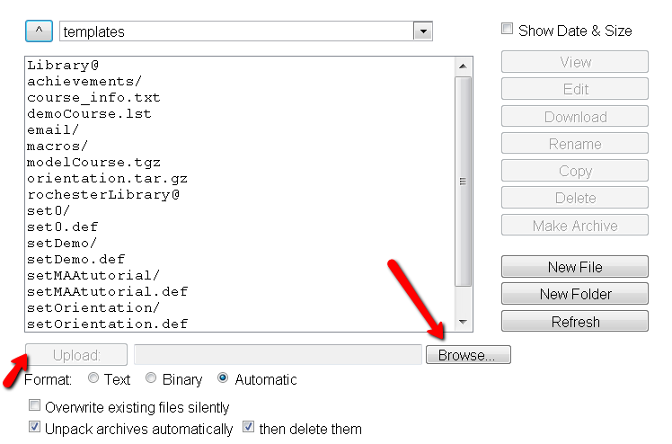

At the bottom of the menu, click **Browse** to find the file to upload. Click **Upload** to upload your file. Your file will appear in the above list with a .csv extension. Click on the file and then click on **Rename** on the right. Remove .csv and replace it with .lst (lower case) and click “Rename.”

Now click on **Classlist Editor** in the WeBWorK main menu on the left of the screen.

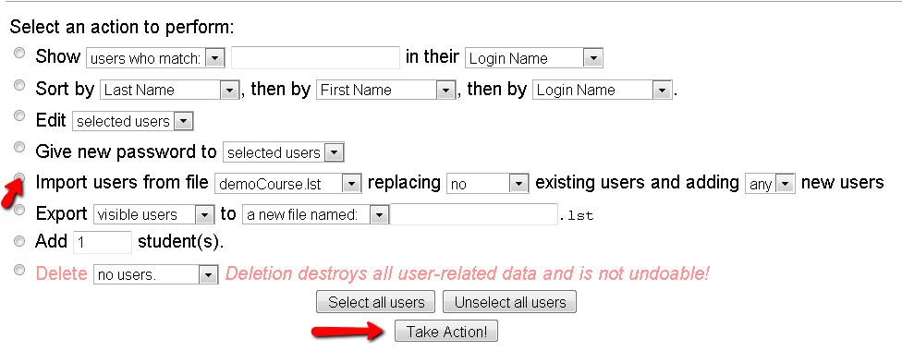

In the Classlist Editor, select the action "**Import users** from file ..." and choose your classlist file.  It should appear in the list in the box.

Press the **Take Action** button, and you should be done. Scroll to the bottom of the screen to make sure that the students have been added to the classlist.

To **add a few students to the class**, choose Classlist Editor from the WeBWorK main menu on the left of the screen.

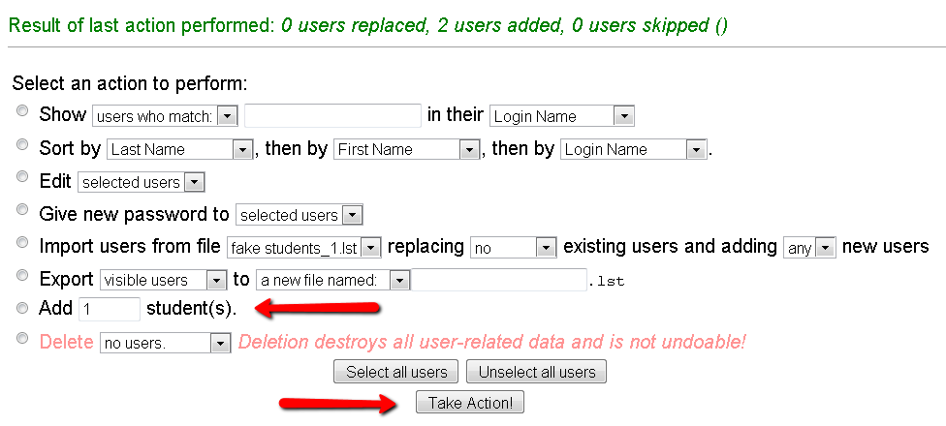

Click the **Add** ___ student(s) button (fill in the blank with the number of students you would like to add), and then click **Take Action!** at the bottom. The screen below will appear, and you can fill in the required information. The only fields that **must** be filled out are Student ID and Login Name. After the information is entered, click **Add Students** at the bottom of the screen.

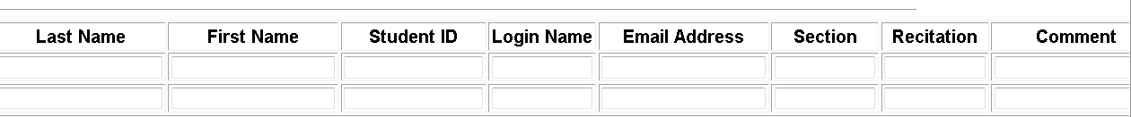

**Creating a Homework Set**

Choose **Library Browser** from the WeBWorK main menu on the left to see the following:

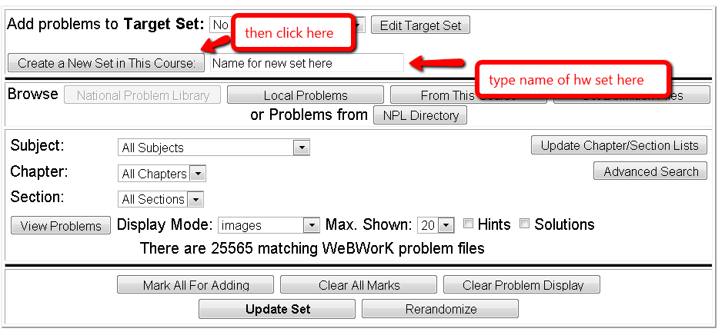

Type in the name of your homework set in the box next to **Create a New Set in This Course**, and click the button. The name will appear as the Target Set.

Under “Browse” choose the source for the problems, and then click on **View Problems**. Select the problems you would like to add to the homework set and click “update set.” **NOTE:** You must select “Update Set” **before** you go to the next page of problems.

Go to **Homework Sets** Editor from the WeBWorK main menu on the left of the screen.

You will see the homework sets listed at the bottom of the screen.

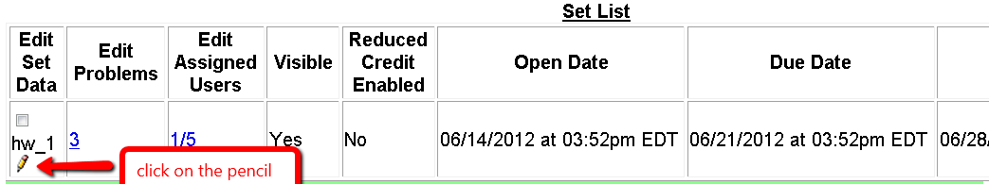

Click on the pencil icon next to the homework set to edit the information for the set. The box below will pop up.

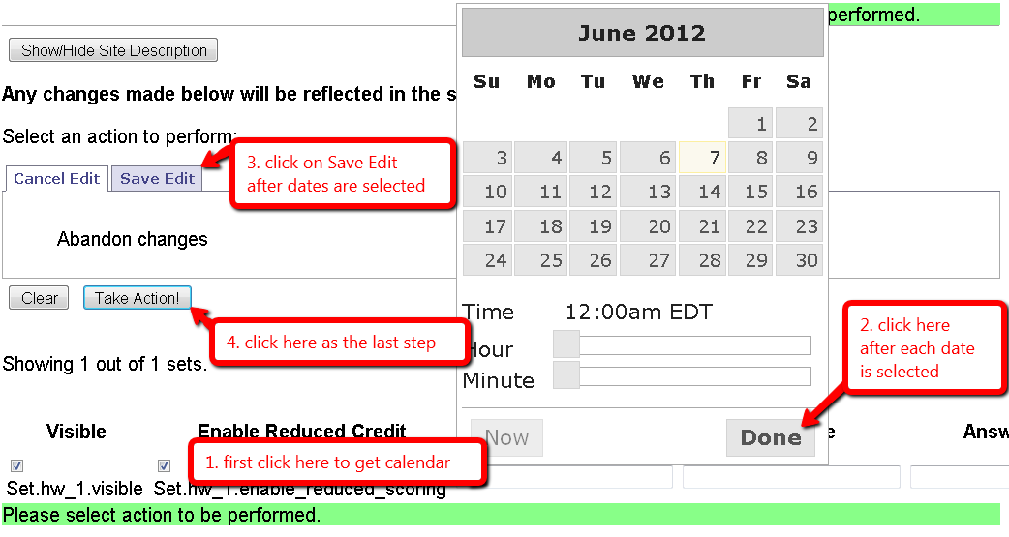

Click in each of the three boxes “Open Date”, “Due Date”, “Answer Date,” and a calendar will pop up. Select the dates when the homework set will open, when it will be due, and when answers will be available. Use the sliders to set the times. Click “Done”on the calendar each time to move to the next field. Click on **Save Edit**, and finally click on **Take Action** to save the dates.

**Assigning the Homework Set to Students**

Go to **Instructor Tools** from the WeBWorK main menu on the left of the screen to see the following:

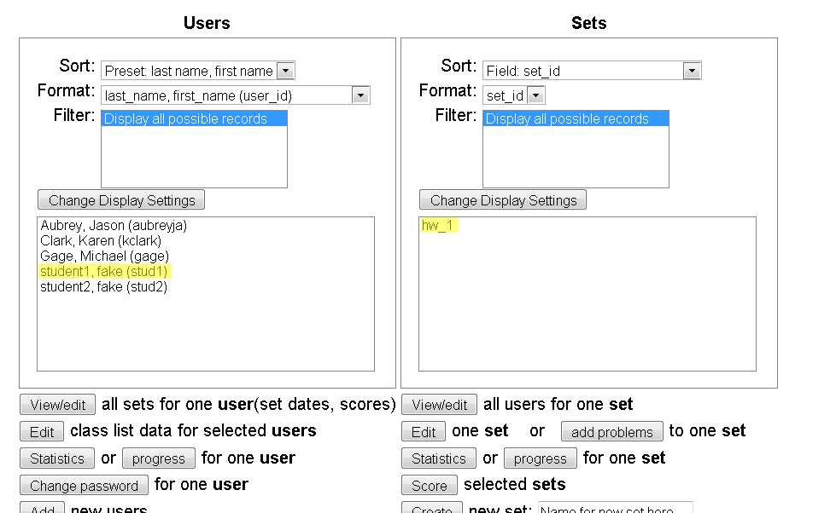

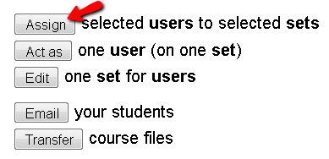

Highlight the students on the left, and the problem set on the right, and click on **Assign** to assign the homework set to selected students. To highlight more than one student, hold down the control key while using the mouse to select the students.

**Scoring the Homework Set**

Select **Scoring Tools** from the WeBWorK main menu on the left.

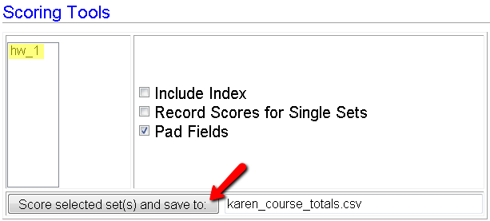

Highlight the homework set on the left and click on **Score selected set**. The grades for the WeBWorK set will be saved to a file for you immediately below the box. You can click on it and save it to your computer. You may score the homework set(s) after the due date, and you may score multiple homework sets at a time by selecting them from the list on the left of the box.

**Monitoring Student Progress**

By selecting **Student Progress** from the WeBWorK main menu on the left of the screen, you can monitor how students are performing on the homework sets. You have a choice of seeing the scores by homework set or by student. You can see this data before the set is due to monitor when students are doing the homework.

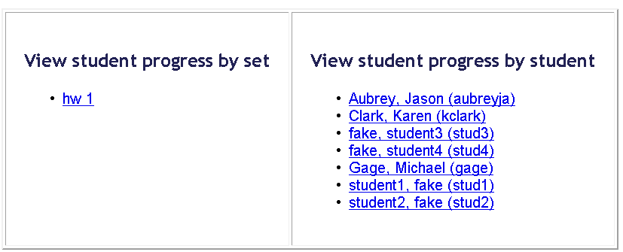

If you choose a particular homework set, you’ll see a table summarizing student performance. Under “Problems,” you can see the number of attempts on each problem, and whether the student finally got the problem correct (indicated by a “C”).

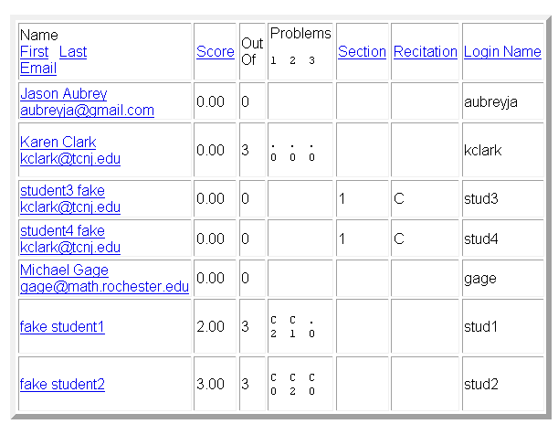

If you choose a particular student, you will be able to see progress on each homework assignment.

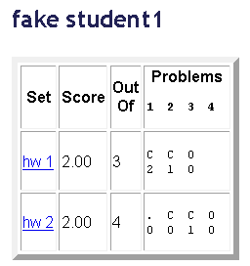

In the example above on hw1, the student answered the first two problems correctly, with three attempts on problem 1 and two attempts on problem 2. For hw 2 the student looked at problem 1 but didn’t attempt it, answered problem 2 correctly on the first attempt, answered problem 3 correctly on the second attempt, and didn’t look at the fourth problem.

**Changing a Student’s Password**

Select **Instructor Tools** from the WeBWorK main menu on the left of the screen to see the following:

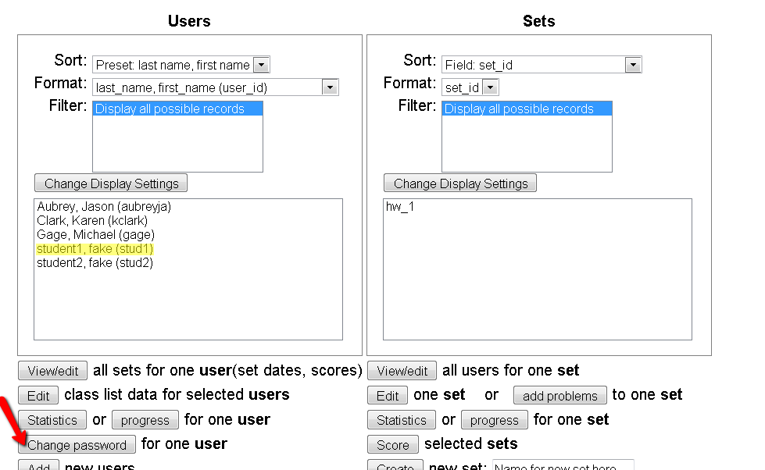

Select the student from the list on the left, and then click on **Change Password** below. You’ll see something like this:

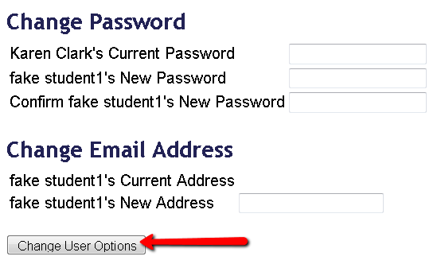

Enter the information and click on **Change User Options** to change the student’s email and/or password.

**Viewing a problem in the homework set for an individual student**

Select **Classlist Editor** from the WeBWorK main menu on the left. Scroll down to see the classlist and click on an individual student:

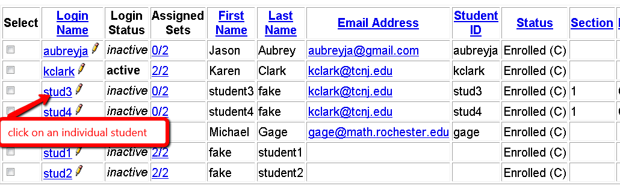

You will now see the list of homework assignments for the student:

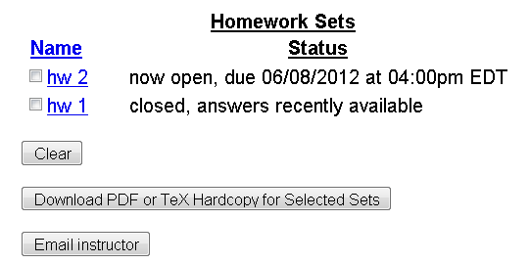

See the notice in the upper right corner of the screen:



When you are done looking at the student problem sets, click on **Stop Acting**.

Before doing that, you may select a problem set and see individual problems as the student sees them.

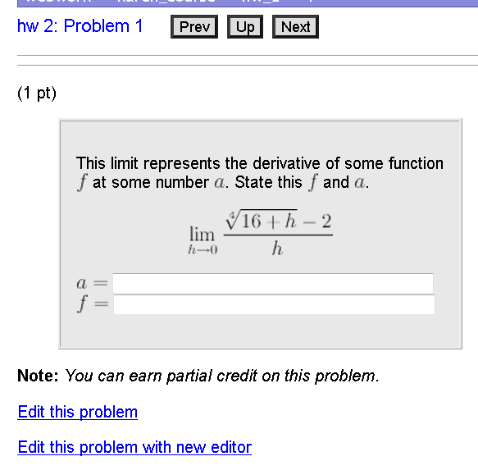

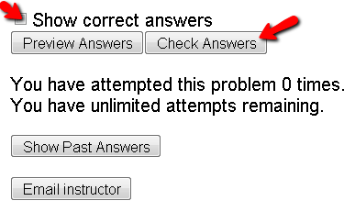

By selecting the box next to Show correct answers and then clicking on **Check Answers**, you can see the correct answer for the problem:

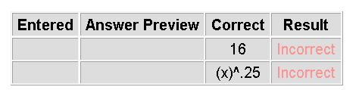

You may also see the student’s attempts at the problem by clicking on **Show Past Answers**:

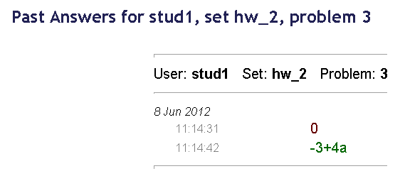

The table indicates the date and time of the attempt, with correct answers in green.

**Changing the due date for an assignment**

Select **Homework Sets Editor** from the WeBWorK main menu on the left.

You will see the homework sets listed at the bottom of the screen:

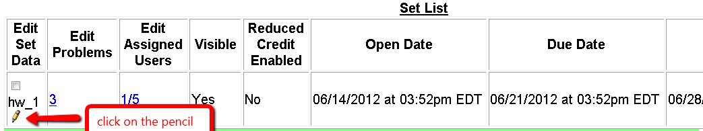

Click on the pencil icon next to the homework set to edit the information about the set. The box below will pop up:



Click in each of the three boxes “Open Date”, “Due Date”, “Answer Date,” and a calendar will pop up. Select the dates for when the homework set will open, when it will be due, and when answers will be available. Use the sliders to set the times. Click “Done” on the calendar each time to move to the next field. Click on **Save Edit**, and finally click on **Take Action** to save the dates.

**Changing the due date for an individual student**

Go to **Instructor Tools** from the WeBWorK main menu on the left of the screen:

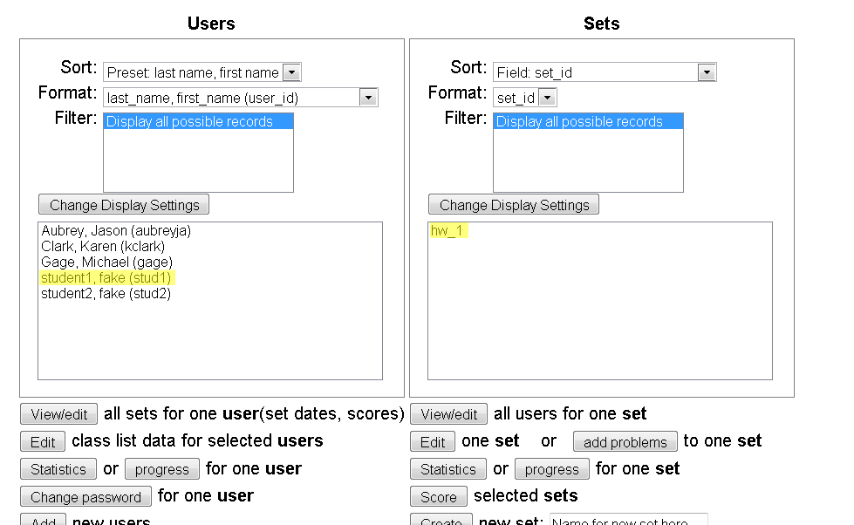

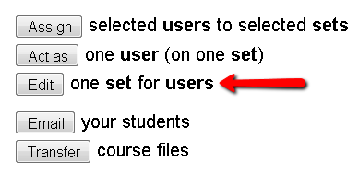

Highlight the student on the left, and the problem set on the right, and click on **Edit** one set for users:

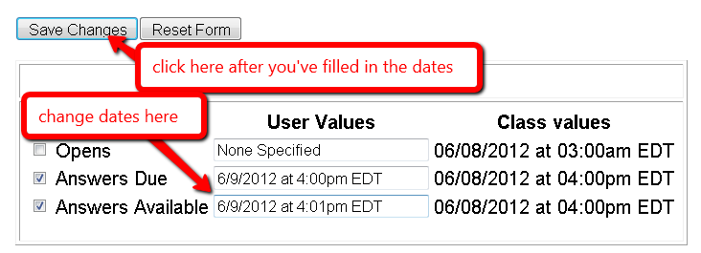

Check the boxes on the left corresponding to the changes you’d like to make. In the text boxes, type in the new date, and then click on **Save Changes** above.

**Changing the order of problems in a problem set, changing the weights of individual problems, changing the number of allowed attempts for a problem.**

Select **Homework Sets Editor** from the WeBWork main menu on the left of the screen:

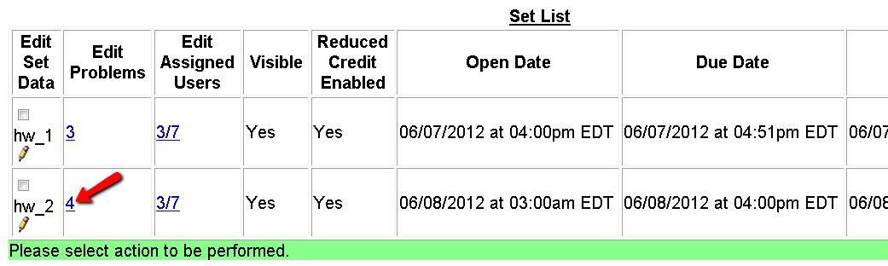

Click on the entry in the “Edit Problems” column for the appropriate homework set. For instance, to change the problems in homework set 2, click on the number “4” in the “Edit Problems” column.

Scroll down to see the information on individual problems:

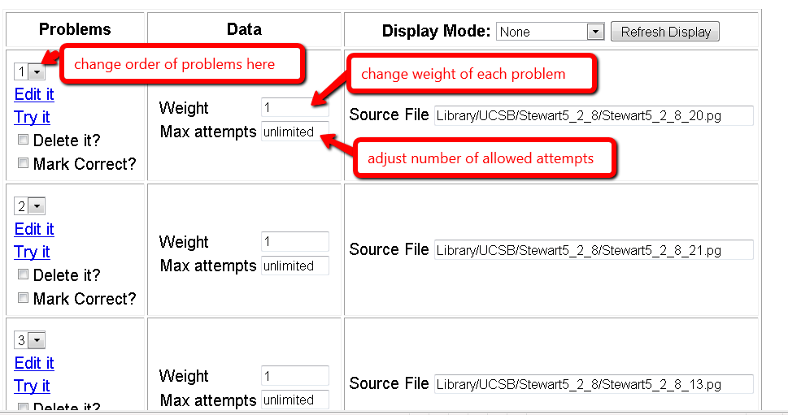

In the “Problems” column, you may use the dropdown menu to change the order of the problems.

In the “Data” column, you may change the weights of each problem, and change the number of allowed attempts. You can change the Display Mode in the right column by using the dropdown menu. If you select “Images” and then click on **Refresh Display**, you will see the problems themselves rather than the Source Files. After making any changes, make sure to click on the Save Changes button.

**Removing Students**

Select **Classlist Editor** from the WeBWorK menu on the left of the screen:

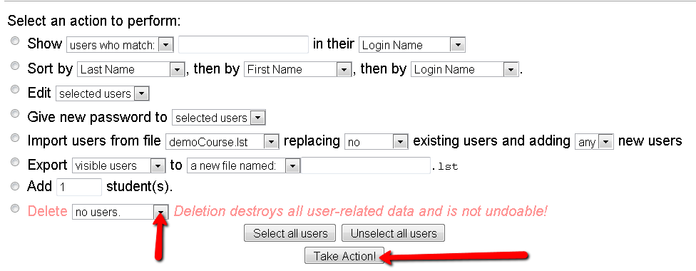

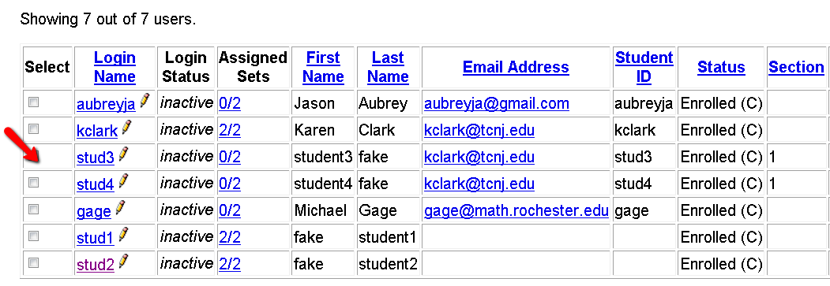

Select the student you wish to delete from the class by clicking the box in the first column, to the left of the student’s name and then choose selected users from the dropdown menu next to Delete above the classlist. Click on **Take Action!** and the student will be deleted from the class.

**Emailing Students**

Click on **Email** on the WeBWorK main menu on the left of the screen:

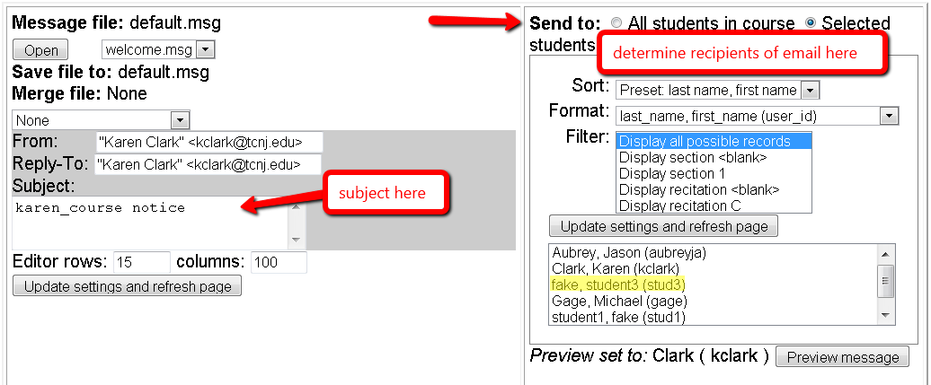

You can now edit the subject (on the left), and on the right either choose All students in course, or Selected students. Scroll down to the bottom of the screen and insert your message into the text box:

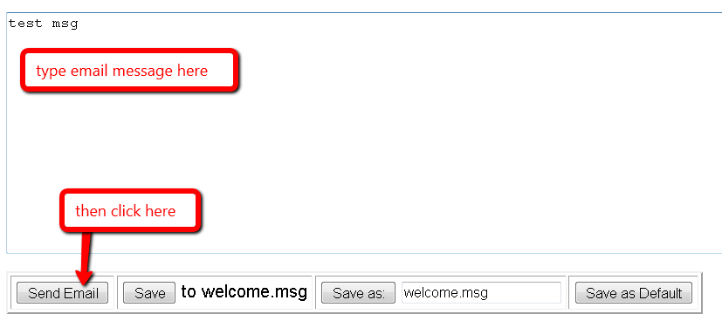

Finally, click on **Send Email** (bottom left) to send your message.

**Changing a seed in a problem for an individual student**

Click on Instructor Tools on the WeBWorK main menu on the left:





Select a student from the list on the left, and a homework set from the list on the right, and then click on **Edit** one set for users. Scroll down on the screen that pops up to see something like the following:

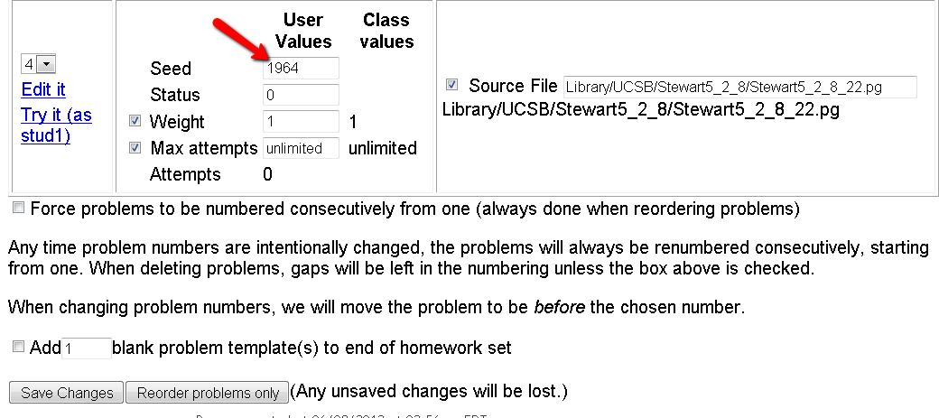

You may now change the seed for an individual problem (for a particular student). Remember to click on **Save Changes** at the bottom.

**Allowing students to get reduced credit for late WeBWorK submissions**

You may set up your course to allow students to submit WeBWorK assignments after the deadline, for reduced credit. To do this, select Course Configuration from the WeBWorK main menu on the left of the screen:

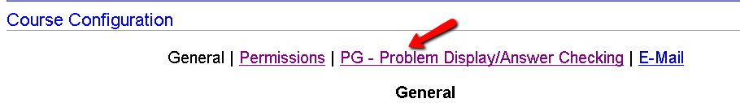

In the display at the top of the screen select PG-Problem Display/Answer Checking.

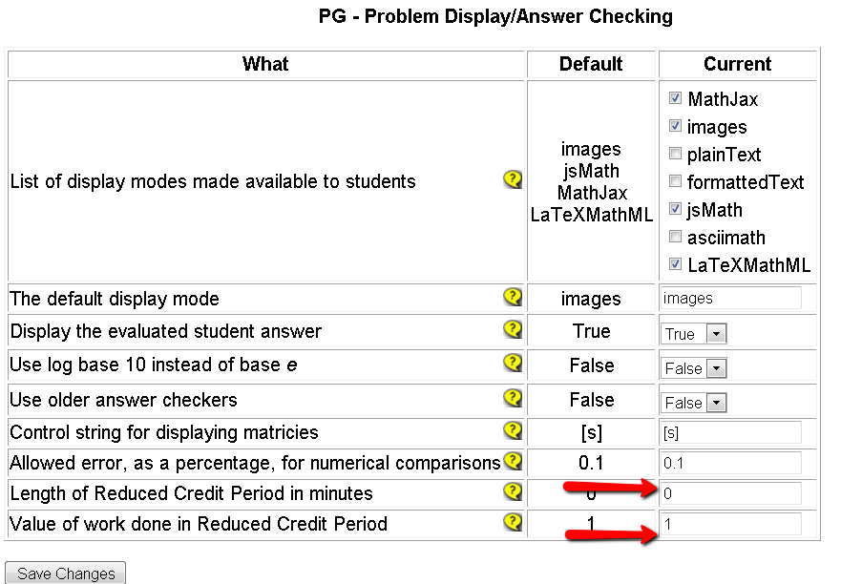

The value (a number from 0 to 1) corresponding to “Value of work done in Reduced Credit Period” is the percentage the work will count after the due date for the assignment has passed. For instance, if you would like to allow students to do homework problems after the due date for 75% of the original credit, you would fill in 0.75 in this last entry on the table. The Length of Reduced Credit Period in minutes is the amount of time students may be given for completing problems at reduced credit. For instance if you would like to allow students to have a grace period of three days, the entry in that row of the table would be filled in as 3*24*60.

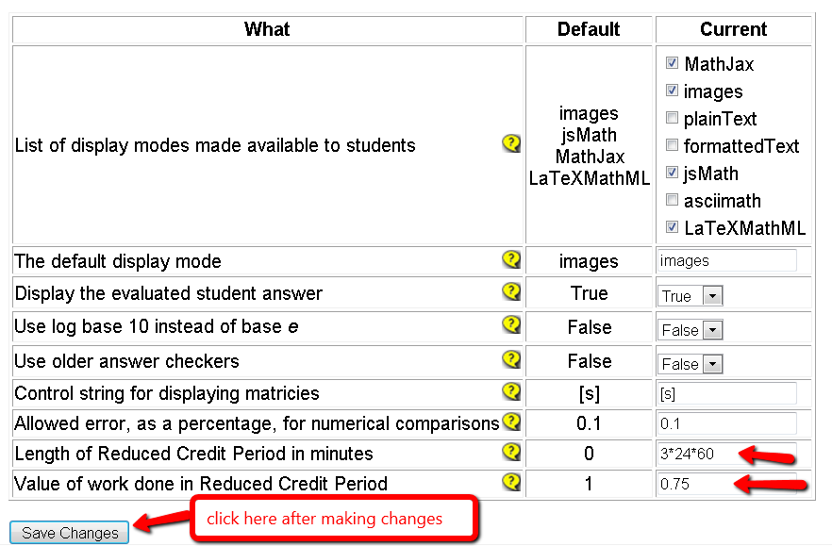

Make sure to click on **Save Changes** after filling in the values for reduced credit preferences.

**Note:** If you are using the reduced scoring option on a homework assignment, when you set the due dates in the Homework Sets Editor, you must set the due date and time as the end of the reduced credit period. For instance, if you would like your assignment to be due on Wednesday for full credit, but students may do the problems until Saturday for reduced credit, you must enter **Saturday**’**s** date as the due date for the assignment.

If you do not want a particular assignment to be eligible for reduced credit, you must make sure the enable reduced scoring option is **not** selected when you set the due dates in the Homework Sets Editor.

Here’s what the student sees if they work on the assignment before the due date for full credit.

From the student’s home screen:

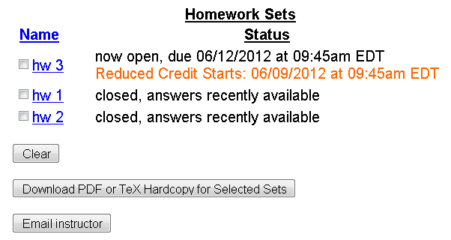

From the individual assignment:

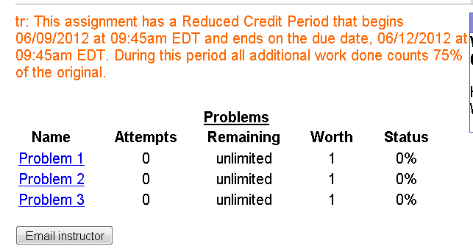

Once the deadline for full credit has passed, the student sees something like the following in each individual problem:

